

MINI PROJECT REPORT ON

**“ATTENDANCE RECORDER Using RFID and ARDUINO”**

SUBMITTED BY:

**MANISH M [1NH18EC066]**

**SOUVIK MANNA [1NH18EC107]**

**CHAITANYA REDDY [1NH18EC065]**

**VAMSI KRISHNA [1NH18EC083]**

Under the guidance of

**MOHAN KUMAR NAIK**

Professor, Dept. of ECE, NHCE, Bengaluru.

# 

# NEW HORIZON COLLEGE OF ENGINEERING

(ISO-9001:2000 certified, Accredited by NAAC ‘A’, Autonomous college permanently affiliated to VTU)Outer Ring Road, Panathur Post, Near Marathalli, Bengaluru-560103

## NEW HORIZON COLLEGE OF ENGINEERING

## DEPARTMENT OF ELECTRONICS AND COMMUNICATION ENGINEERING



**CERTIFICATE**

Certified that the mini project work entitled “**ATTENDANCE RECORDER Using RFID and ARDUINO**” carried out by **MANISH M** [1NH18EC066],**SOUVIK MANNA** [1NH18EC107],**CHAITANYA REDDY** [1NH18EC065],**VAMSI KRISHNA** [1NH18EC083] bonafide students of Electronics and Communication Department , New Horizon College of Engineering, Bangalore.

The mini project report has been approved as it satisfies the academic requirements in respect of mini project work prescribed for the said degree.

Project Guide HOD ECE

------------------------- -------------------------

**External Viva**

Name of Examiner Signature with Date

1.

2.

**ACKNOWLEDGEMENT**

The satisfaction that accompany the successful completion of any task would be, but impossible without the mention of the people who made it possible, whose constant guidance and encouragement helped us succeed.

We thank **Dr. Mohan Manghnani**, Chairman of **New Horizon Educational Institution**, for providing necessary infrastructure and creating good environment.

We also record here the constant encouragement and facilities extended to us by **Dr.Manjunatha**, Principal, NHCE and **Dr. Sanjeev Sharma**, head of the department of Electronics and Communication Engineering. We extend sincere gratitude to them.

We sincerely acknowledge the encouragement, timely help and guidance to us by our beloved guide **Mohan Kumar Naik** to complete the project within stipulated time successfully.

Finally, a note of thanks to the teaching and non-teaching staff of electronics and communication department for their co-operation extended to us, who helped us directly or indirectly in this successful completion of mini project.

**MANISH M [1NH18EC066]**

**SOUVIK MANNA [1NH18EC107]**

**CHAITANYA REDDY [1NH18EC065]**

**VAMSI KRISHNA [1NH18EC083]**

**TABLE OF CONTENTS**

ABSTRACT

**CHAPTER 1**

INTRODUCTION…………………………………………………………………………………3

**CHAPTER 2**

LITERATURE SURVEY………………………………………………………………………… 4

**CHAPTER 3**

PROPOSED METHODOLOGY…………………………………………………………………..6

**CHAPTER 4**

PROJECT DESCRIPTION ………………………………………………………………………..9

4.1 HARDWARE DESCRIPTION……………………………………………………………….11

4.2 SOFTWARE DESCRIPTION…………………………………………………………………19

**CHAPTER 5**

RESULTS AND DISCUSSION…………………………………………………………………22

**CHAPTER 6**

CONCLUSION AND FUTURE SCOPE …………………………………………………………27

REFERENCES…………………………………………………………………………………….57

APPENDIX………………………………………………………………………………………..58

**LIST OF FIGURES**

|  |  |  |  |
| --- | --- | --- | --- |
| **SL**  **No**  1 | **FIGURE**  **No**  1.1 | **FIGURE DESCRIPTION**  Block diagram | **Page**  **No**  11 |
| 2 | 1.2 | Proposed system block diagram | 12 |
| 3 | 1.3 | Flow Chart | 13 |
| 4 | 1.4 | Circuit Diagram | 15 |
| 5 | 1.5 | Arudino Uno | 17 |
| 6 | 1.6 | LCD Display | 19 |
| 7 | 1.7 | MFRC522 | 20 |
| 8 | 1.8 | GSM SIM900A | 21 |
| 9 | 1.9 | RFID Cards | 22 |
| 10 | 2.1 | Main Menu And Main Page | 23 |
| 11 | 2.2 | Upload Window | 23 |

### LIST OF TABLES

|  |  |  |  |
| --- | --- | --- | --- |
| **SL**  **No** | **Table**  **No** | **TABLE DESCRIPTION** | **Page**  **No** |
| 1 | 1.1 | Pin configuration of 20x4 LCD display | 19 |
|  |  |  |  |

**ABSTRACT**

A security system is basically an integrated system. Compact means hardware control by software. Here, the software that uses a microcontroller controls all the hardware components. Microcontrollers play an important role in a system. The main purpose of the system is to uniquely identify a person and provide security. This requires a unique product that has the ability to distinguish a different person. This is made possible by a new technology called RFID. The main parts of the RFID system are the RFID tag and the RFID reader. In this system, the RFID reader and the RFID tag used operate at a frequency of 125 KHz. The internal memory of the microcontroller is used to store the details. This report provides a clear picture of the hardware and software used in the system. It also provides an overview with a detailed description of how the system works. Indicator terms: RFID Tag, RFID Reader, Arduino, LCD, EEPROM, BMI. This project was developed using a Radio Frequency Identification System (RFID) and a student card to obtain the attendance of the students. Before this project, teachers needed to use paper to get student attendance. There were many problems using the paper as an aid to the students, such as cheating. This project can help teachers reduce these problems by designing automated attendance using RFID and student cards.

**CHAPTER 01**

**INTRODUCTION**

Today, the attendance system in schools and universities is generally paper-based. So sometimes this process causes errors and also takes longer. So this project uses RFID technology to take note of each student who enters the classroom and also to calculate the time spent in class. In this proposed system, each student is assigned an RFID tag. The assistance process can be done by placing the card near the RFID reader and not only this but we have introduced some more functions in this project.

College attendance is usually done on paper, which can sometimes lead to mistakes. Taking attendance manually takes more time. So in this project we have designed an RFID based assistance system using Arduino and the MFRC522 RFID module. In this system, each student receives an RFID card as her identification card and her attendance is marked when she touches her card with the RFID reader.

The MFRC522 RFID reader is a very simple but effective module. It is an RFID module and is used to scan RFID cards. It is a new technology and it is expanding day by day. Today it is used widely in offices where employees issued the RFID card and their presence is tagged when their card is touched by the RFID reader. We have seen in many movies that when someone places a card in a machine, the door opens or closes. In short, it is a new emerging technology that is quite useful. In this project, we will create an MFRC522 RFID based time attendance system using the Arduino board. When you pass an RFID tag next to the RFID reader, the user's UID and time are saved on an SD card. It also shows whether you are late or on time based on the preset hour and minute. For this, we are interconnecting the SPI RFID module MFRC522 with Arduino. We are also interconnecting the SD card module as a data logger where the data is saved in text format. Similarly, the DS3231 or DS1307 RTC module is used to store time information.

The RFID based attendance system is an interesting project that can be used in a variety of locations, for example in schools, students, teachers, and private institutions to schedule attendance, schedule monthly work hours and automatically calculate payroll. Registered in the office and other similar applications. RFID based time and attendance management systems can be designed with a variety of microcontrollers, for example 8051 series controller, AVR controller, PIC or ARM. Similar RFID assist systems can be developed using the popular Arduino and Raspberry Pi development boards.

The choice of a microcontroller or development board depends on the features and add-ons you intend to integrate into the system. Example: - If you want to export all the data recorded on the system to a web platform (for cloud host transfer) at the end of each week, it is better not to use the 8051 chain controller to design such a system. This type of system that connects to the Internet can be designed efficiently (and easily) using AVR At mega Series controllers. If you are designing for a hobby purpose, you can easily design this system with Arduino. With Arduino we will build an RFID based presence system.

This RFID based attendance management system is based on a few simple concepts. We store a batch of RFID card data in our system, to transmit 3 or 10 RFID card data. When the person with the correct RFID card (which matches the data pre-loaded into our software / system) comes and passes their RFID card, their arrival time will be stored on the system. When same person passes their RFID card again, system will save it as downtime and add it to total working time. The main idea of ​​a radio frequency based attendance system is to be present. The RFID card must be shown in front of the RFID reader, and then the person's presence is recorded in the microcontroller memory. RFID based attendance system is one solution to improve student safety by increasing system efficiency instead of photo ID, which also helps workers to be present at their workplace. The ability to uniquely identify each person based on the RFID tag type ID card facilitates the process of allowing security access easier, faster and more secure than the traditional method. The cardholder needs to put it in the card reader, and if any invalid card appears, he will be allowed to enter the command While the bell is playing.

Attendance goes beyond the old attendance system of having to take it voluntarily. Design a supported database as mentioned earlier. Develop a smart attendance system to be implemented in BMI (biomedical devices) classes, laboratory, etc. by integrating the program with specific equipment. The current system barcode is used on the student ID card for attendance. It is a visual representation of data that is scanned and interpreted to obtain information. At the same time, the traditional method of calling names / scroll numbers or signing papers in each lecturer / lab is very time consuming, unsafe, ineffective, difficult and unified. They present their precious time. So often the college does not take proper attendance. Acting attendance is always an issue at most universities. Government and law enforcement agencies are required to establish a full attendance system.

The concept “Internet of Things” (IoT) has

The concept of "Internet of Things" (IoT) has recently attracted increasing interest from academia and industry. The Internet of Things is a situation that provides devices (animals or even humans) with unique identifiers and the ability to automatically transfer data over a network without requiring computer intervention from humans. The Internet of Things is a state in which there are (even) devices Animals or people) are unique identifiers and the ability to automatically transfer data over a network without requiring computer intervention from humans. RFID devices are a key component of wireless microchips of the Internet of Things, which are used to tag objects for automatic identification.

Student attendance is an important part of daily teaching. Traditionally, the teacher is responsible for assigning class names. Therefore, it is not flexible to generate reports or statistics as it takes time. Researchers have suggested a number of techniques, including barcode-based attendance, face recognition, and fingerprint recognition, to escape the manual attendance process and sign the paper. However, these systems face some obstacles and difficulties . The most common way to track a student's attendance is to manually call a name or sign an attendance sheet. For a more powerful class, both methods are difficult. The easy calling method not only causes fake attendance in a large classroom, but also takes longer to call all students . There are also major problems when converting paper data into an electronic form for use in electronic records for students to calculate total attendance at various levels (such as subject, study program, college or university).

RFID (Radio Frequency Identification) is a new technology that uses electromagnetic or electrostatic coupling on the radio frequency (RF) side of the electromagnetic spectrum to uniquely identify an object, animal, or person. RFID tags are not an enhanced barcode because some tech advocates want you to believe them. The RFID system consists of three components: an antenna, a transmitter and a receiver (often built into a reader), and a transmitter and receiver (tag). The antenna uses radio frequency waves to transmit a signal that activates the transmitter and receiver. When activated, tag information is sent to the antenna. RFID technology differs from barcode.

The tag can be read using RFID RF, meaning the RFID reader can read remotely through your clothes, wallet or purse. In addition to the RFID tag, each tag contains a unique ID. The technology used in RFID dates back to the early 1920s. In our country, this technology is less frequent and biometric systems using fingerprints are more commonly used. Our government is deficient in this technology by using it as an RFID I.C (Identification Card). In some parts of our country, people prefer to use barcodes that are cheaper than RFID. The technology has spread so fast that in a few years, the possibility of replacing the barcode system with RFID will become a reality. Nowadays, there are many universities across our country, and each student has up to ten thousand students. It can be a problem to get special attendance to handle a large amount of students. At present, the process of attendance at most universities still uses the manual process. The manual process means that at the beginning of the class (or lecture), the lecturer will present an attendance paper and the students will check their name and sign it. At the end of the class, the lecturer will return the paper and record it.

In general, it takes a lot of time for all students to sign the attendance paper, especially foreclosures with a large number of students. Students forget to sign that attendance, and it is assumed that they will not attend that class. The problem also occurs when the lecturer forgets to bring the attendance paper to class. Students are required to write their name on a piece of paper and sometimes use this opportunity to deceive the student in the process of getting present. The ideal solution to this problem is to design a system that automatically records attendance. This project is based on the RFID system and is used to automatically record student attendance. This project will use the student ID card as an RFID tag and RFID reader. This RFID system will be integrated with a software. This method is more effective in preventing problems in the process of getting attendance voluntarily.

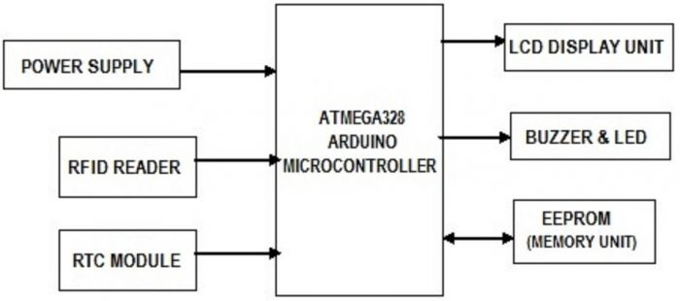

Fig.1.1 Block diagram

**CHAPTER 02**

**LITERATURE SURVEY**

To design and define an electronic attendance system, several technologies have been developed. In this chapter, we present various concepts about electronic presence system technologies

**EMPIRICAL REVIEW**

The radio frequency identification system includes devices known as investigators or readers and labels, also known as RFID software or RFID middleware. RFID tags are of two main types, including active tags and passive tags. However, this system does not include a door unit that allows access only to registered users. Basic Attendance System of Mohammed Firdaus with RFID and Student Card.

**THEORETICAL LITERATURE**

It is said that the roots of radio frequency identification technology can be traced back to World War II.. Radar was used by the Germans, the Japanese, the Americans, and the British. In 1935 the Scottish physicist Sir Robert Alexander Watson-Watt was covered. The problem is that there is no way to determine which aircraft belong to the enemy and who the country pilots are returning from a mission.Radio Frequency Identification (RFID) research and discovery sincerely began in the 1980s. RFID is commonly used to transfer and receive information wirelessly. RFID Reader Sand tags communicate over long distances using radio waves. The RFID system has many advantages, including their price, size, memory capacity, and capacity. A pure memory-based RFID chip without a co-processor is inexpensive, and its footprint is small and is commonly used in caromobilizer applications, where the IC must fit into a small glass tube buried in the key. RFID fast processing speed is also essential.

**CHAPTER 03**

**PROPOSED METHODOLOGY**

In the proposed system, a student automation system project was developed as an important application to automatically maintain attendance with RFID. Our specific system mainly consists of 20X4 LCD, RFID reader, RFID tag, Arduino uno and momentum switches. Initially the LCD unit displays five options to start the process. These are 1: Recording, 2: Attendance, 3: Delete all records, 4: Results. So first in our specific model, we need to register students or link the database to its exemption database and then we can start participating. In the registry, student / employee information is first stored in a database.

After that the student can attend. We used the device's EPROM memory to protect the candidate's presence. We are blocking the diagram of our specific system fig.1.

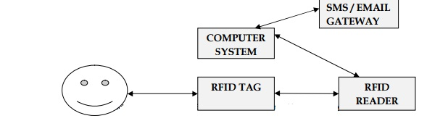

Fig.1.2 Proposed system block diagram

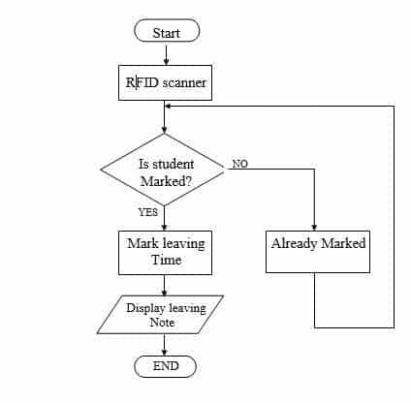

Fig.1.3 Flow Chart

In this project we used RFID reader, RFID tags, arduino UNO, server based database and C #. On the first page of the user interface C # we are given four options, namely sign in, student and exit. The login option is for management where you can log in and access the data by entering the login details. I.e. username and password. With the Student option always open, the user interface will always open, marking attendance whenever the student scans his card, saving it to the database on a regular basis and showing the timetable there. The About section contains details about the project and you can leave the application by clicking the Exit button. By logging into Management you can upload data, marks, assignment and fee notification, view the same data, and search for data. Assignment and fee notice will be emailed. For everything we have created a separate window, your PC must be connected to the Internet and RFID as the application cannot be accessed in simple terms until the serial port is opened or the arduino is not connected. As we mentioned above, each RFID tag has a unique number, so whenever a student scans his card, the RFID tag number is sent to the database and the unique tag number is each student's identity.

It includes a group of technologies known as automatic identification and data capture (AIDC).AIDC methods automatically identify objects, collect data on them, and transfer data directly to computer systems with or without human intervention.

RFID methods use radio waves to achieve this. At the most basic level, RFID systems consist of three components: an RFID tag or smart tag, an RFID reader, and an antenna. RFID tags consist of an integrated circuit and an antenna that are used to transfer data to an RFID reader (also called a query). The reader then converts the radio waves into more useful data. The information collected from the tags is transferred to a host computer system via a communication interface, where the data can be stored in a database and then analyzed.

The proposed system provides facilities for each of the students And employees by reducing the time required for absence, as well as, Providing a database system that accommodates all students Information (i.e. there is no need to archive the shelf and paper Works). The system provides facilities for new registration Students and send reports and warnings to them; Show Test results, homework, and other notifications like Staff schedule, lecture cancellations, etc. From the student's point of view, the student will be informed All required information on screen plus a file Warning report absence, if any, as the system provides to the student Attendance mechanism.

**CHAPTER 04**

**PROJECT DESCRIPTION**

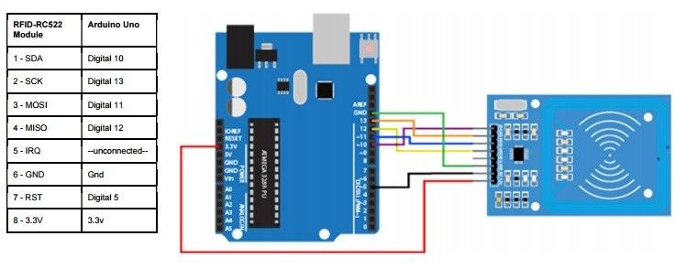

Fig.1.4 Circuit Diagram

Above is the complete circuit diagram for connecting the RFID module to the Arduino. The circuit reads the UID code on the RFID card and the corresponding person's name will be displayed on the 4 x 20 LCD screen. The TX pin of the RFID module is attached to Pin 0 (RX) of the Arduino. The Arduino receives data from the RFID module over this channel.

The 1,2,3,4 button is used to select the menu and various options within the menu. The Arduino pins that the buttons are connected to are configured as "INPUT_PULLUP" within the software. This will eliminate the use of external pull-out resistors by enabling the Arduino's internal pull-ups. The doorbell and the LED are also connected to the 5th, 4th, and 3rd pin of the Arduino respectively. The buzzer beeps when the identification code is received when the card is read by the circuit.

Our system uses a 20 x 4 LCD for display purpose. It's like doing a 20 x 4 LCD unit and connects it to a 16 x 2 LCD, we'd expect it to consist of just a few rows and columns.

**MODULE / COMPONENT DESCRIPTION**

**Arduino Uno**

Arduino Uno is an ATmega328P microcontroller board. Arduino Uno has 14 digital I/O ports 6 of which can be used as PWM outputs, 6 analog inputs, 16MHz quartz crystal, USB interface, power jack, ICSP header and reset button. Both digital 14 pins and analog 6 pins on Uno can be used as input or output, using the pin mode (), digital write () and digital readout () functions. It has a voltage of 5 volts. Each pin can supply or receive 20 mAh depending on the recommended operating conditions and has an internal pull resistance of 20-50 k (default). Maximum value of 40 mA.that should not be exceeded at any I / O terminal to avoid permanent damage For microcontrollers. Uno has 6 analog inputs, numbered A0 to A5, each providing 10 bits of resolution (i.e. 1,024 different values).

Arduino Uno is a microcontroller board based on the ATmega328 .This includes 20 digital I / O pins (6 of which can use PWM6 analog inputs) ، 16 MHz resonator reset ، USB connection Power connector ، In-circuit system (ICSP). It contains everything you need to support a microcontroller Connect it to the existing or use AC adapter or battery.

One differs from all previous boards in that it does not use the FTDI USB to Serial chip.Instead, the ATmega16U2 features have been programmed to function as a USB to serial converter.This helper microcontroller has its own USB bootloader, which allows advanced users to recreate it.

Arduino has a large support suite, a wide range of support libraries, and additional hardware "shields" (for example, you can easily make Arduino wireless with our Wixel shield), making it a great introductory platform for embedded electronics. Note that we also offer SparkFun Inventor's Kit, which includes the Arduino Uno along with a variety of components (such as breadboard, sensors, jumper wires, and LEDs) that make.

This is the third edition of Uno (R3), which has a number of changes:

• Changed USB controller chip from ATmega8U2 (8K flash) to ATmega16U2 (16K flash). This does not increase the flash or the available graphics RAM.

• Three new pins have been added, all of which are duplicates of the previous pins. I2C pins (A4, A5) were also ejected on the side of the board near the AREF. The IOREF pin is located next to the reset pin, and it is a duplicate of the 5V pin.

• The reset button is now next to the USB connector, making it easy to access when using a shield.

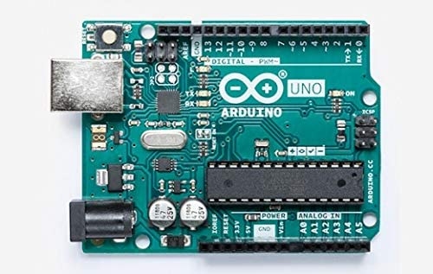

Fig.1.5 Arudino Uno

**20x4 LCD DISPLAY UNIT**

Liquid Crystal Display (LCD) is a flat screen display, optical electronic screen or video screen that uses the light modulating properties of liquid crystals. Liquid crystals do not emit light directly.Here, in this project, we'll be using an alphanumeric 20 x 4 monochrome LCD monitor. 20x4 means that 20 characters can be displayed in each of the four rows of a 20x4 LCD, so a total of 80 characters can be displayed at any time [9]. The LCD accepts two types of signals, one is data and the other is control. These signals are recognized by the LCD module from the RS pin status. Now data can also be read from the LCD, by pulling the R / W pin high. Once the E-pin pulse, the LCD reads the data at the dropping edge of the pulse and executes it, as in the case of a transmission. The LCD takes 39-43 ° C to place a character or execute a command. Except for wiping the screen and looking for the cursor to the main position, it takes 1.53ms to 1.64ms. Any attempt to send any data before this interval may result in data readability or current data execution failure on some devices. Some devices compensate for the speed by storing the incoming data in some temporary logs. LCD monitors contain two random access memory (RAM), to designate DDRAM and CGRAM. DDRAM records where a character will be displayed in the ASCII map. Each byte of DDRAM represents a unique area on the LCD screen.

The LCD controller reads data from the DDRAM and display it on the LCD screen. CGRAM allows the user to define their own custom characters. For this purpose, address space is reserved for users for the first 16 ASCII characters. Once CGRAM is set to display characters, users can easily display their custom characters on the LCD [10]. Data Displays data represented in random access memory (DDRM) 8-bit character codes. Its extensive capacity is 80 x 8 bits or 80 characters. Area public data on non-display DDRMs can be used as random access memory. Character Generator ROM generates 5 x 8 point or 5 x 10 point character styles from 8-bit character codes. Can generate 208 5 x 8 character patterns and 32 5 x 10 character patterns. The CGRM area is used to create custom characters on the LCD screen. In character generation RAM, the user can change the character styles according to the program. 5 x 8 dots can write eight letter patterns and 5 x 10 dots can write four letter patterns.

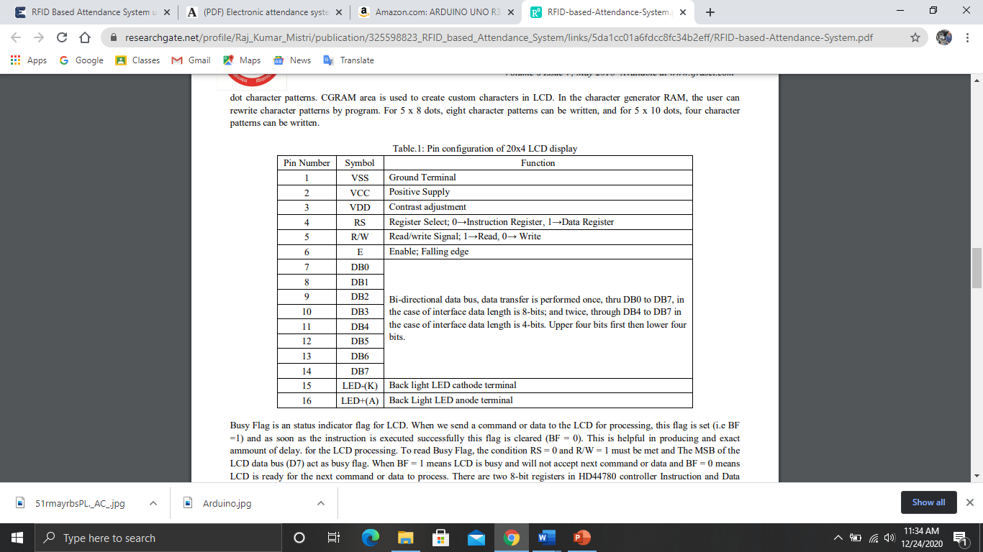

Table.1.1: Pin configuration of 20x4 LCD display

Busy Flag is an status indicator flag for LCD. When we send a command or data to the LCD for processing, this flag is set (i.e BF =1) and as soon as the instruction is executed successfully this flag is cleared (BF = 0). This is helpful in producing and exact ammount of delay. for the LCD processing. To read Busy Flag, the condition RS = 0 and R/W = 1 must be met and The MSB of the LCD data bus (D7) act as busy flag. When BF = 1 means LCD is busy and will not accept next command or data and BF = 0 means LCD is ready for the next command or data to process. There are two 8-bit registers in HD44780 controller Instruction and Data register. Instruction register corresponds to the register where you send commands to LCD e.g LCD shift command, LCD clear, LCD address etc. and Data register is used for storing data which is to be displayed on LCD. when send the enable signal of the LCD is asserted, the data on the pins is latched in to the data register and data is then moved automatically to the DDRAM and hence is displayed on the LCD.

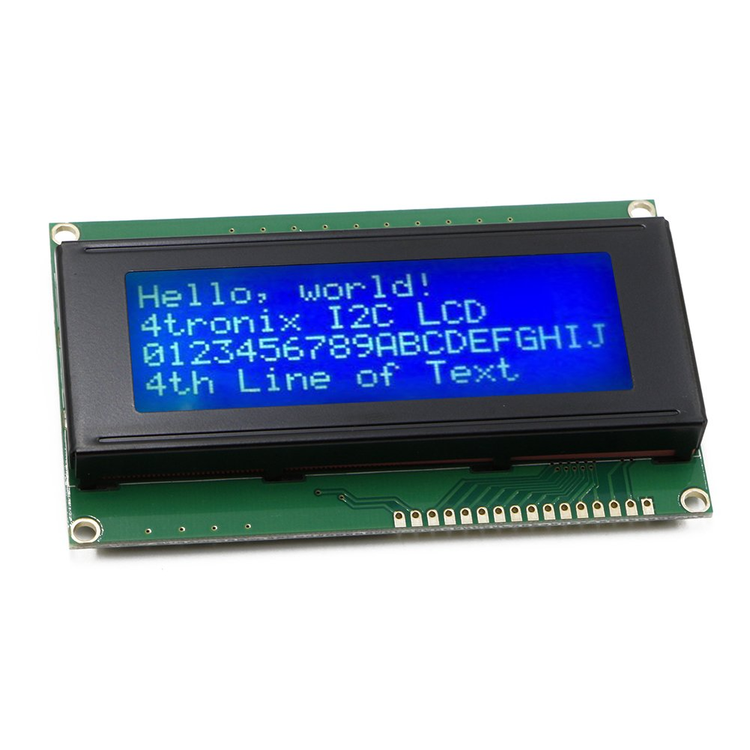

Fig.1.6 LCD Display

Rfid Reader [MFRC522]

Electromagnetic fields are used to automatically identify and track tags attached to radio-frequency identification (RFID) objects. Tags contain information stored electronically. Passive tags collect energy from radio waves interrogated by a nearby RFID reader.Active tags have a local power source (such as a battery) and can operate hundreds of meters away from the RFID reader.RFID involves a set of technologies known as Automatic Identification and Data Capture (AIDC). AIDC automatically identifies objects, collects data on them, and transfers data directly to computer systems with or without human intervention. RFID methods use radio waves. At the most basic level, RFID systems consist of three components: an RFID tag or smart tag, an RFID reader, and an antenna. RFID tags consist of an integrated circuit and an antenna that are used to transfer data to an RFID reader (also called a query). The reader then converts the radio waves into more useful data. The information collected from the tags is transferred to a host computer system via a communication interface, where the data can be stored in a database and then analyzed. There are two types of RFID systems. Active RFID System: Like any external power supply unit or battery, these tag systems have their own source power source. The only obstacle is the lifespan of the power tools. These systems can be used for long distances and for tracking high value items such as vehicles. Passive RFID System: These are systems that receive the tag's power by transferring energy from the reader antenna to the tag antenna. They are used for short-term broadcasting.

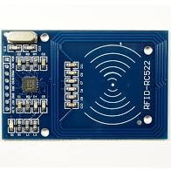

Fig.1.7 MFRC522

**GSM SIM 900A**

The SIM 900A modem can work with its GM operator's SIM card.

The SIM900A GSM / GPRS modem is a plug and play modem with RS232 serial communication support. So the advantage of using this modem is that the RS232 port can be used for communication and developing embedded applications.

Applications such as SMS control, data transfer, remote control and recording can be developed. The SIM 900 modem supports features such as voice calls, SMS, data / fax and GPRS.

The SIM900A module has 6 pins, including pins for Vcc and Gnd, remaining connections 3VR and 3VT (3V Rx & Tx), 5VR and 5VT (5V Rx & Tx):

* Vcc to 5V
* Gnd to Gnd
* 5VR PIN 7
* V5 VT pin 8

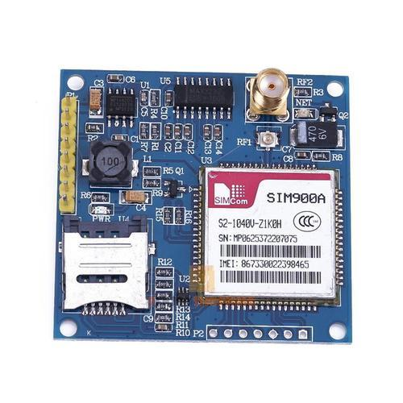

Fig.1.8 GSM SIM900A

**RFID CARDS**

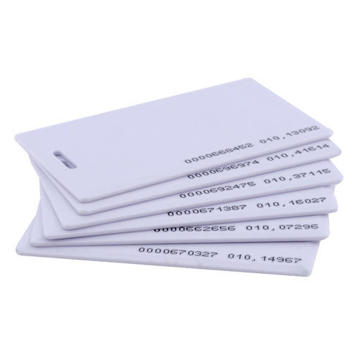 Fig.1.9 RFID Cards

Radio Frequency Identification (RFID) tags or transceivers are small devices that use low-energy radio waves to receive, store and transmit data to nearby readers. RFID tags consist of the following major components: a microchip or integrated circuit (IC), antenna, and a base layer or protective material that holds all components together.

Radio Frequency Identification (RFID) is the use of a radio that is not connected to radio frequency waves to transmit data. RFID tagging of items allows users to automatically and unique identify and track inventory and assets. RFID takes automatic recognition technology to the next level by allowing labels to be read without a line of sight, and depending on the type of RFID, the reading range is between a few centimeters to over 20 meters.

RFID has come a long way since its first application to identify aircraft as friend or foe in WWII. Not only does the technology keep improving year after year, the cost of implementing and using the RFID system continues to decrease, making RFID technology more cost effective and efficient.

**CHAPTER 05**

**RESULT**

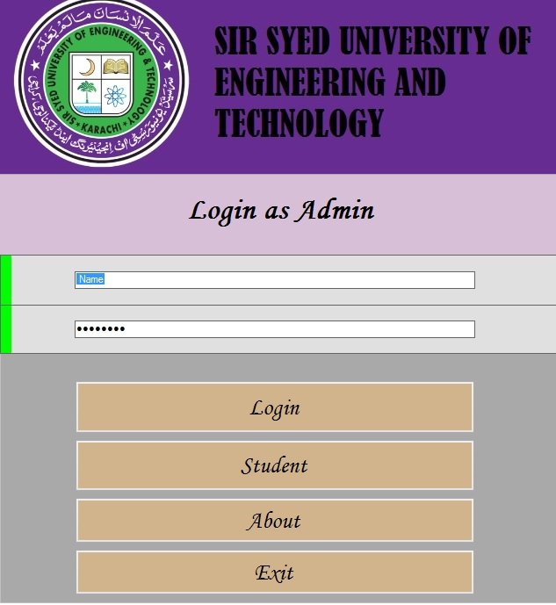

  
Fig.2.1 Main Menu And Main Page

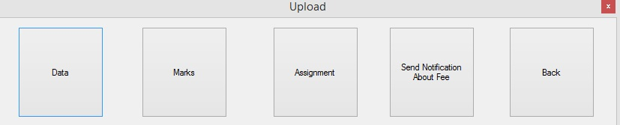

Fig.2.2 Upload Window

**CHAPTER 06**

**CONCLUSION AND FUTURE SCOPE**

The goal of building an RFID-based presence system has been successfully achieved. In terms of performance and efficiency, this project provided a suitable method for recording attendance compared to the traditional method of attendance system. With a database, your data is more organized. This system is also an easy-to-use system as data can be processed and retrieved across the interface, making it a global presence system. Thus, it can be implemented in any academic institution or in organizations.

This project will help any institute to manage its data and this can be improved by adding some new options and components such as you can add GSM and send SMS to the student’s guardian whenever his card is scanned for attendance and you can add many other things. To solve the student attendance issues that are taken using paperwork, we have implemented an RFID based electronic attendance system with an automatic door unit, giving the opportunity for lecturers to have each student attendance at the end of the year. The program thus reduces the risk of fraud on the part of students and facilitates administrative work on the part of the lecturer.

RFID based attendance and attendance system is more secure and responsive compared to other system like biometric. The main feature of RFID is contactless and line-of-sight operation. The sign works in any environmental conditions. With the Arduino platform it gets faster response and while burning the code it is like a plug and play device. User can change the application accordingly with the Arduino.

**REFERENCES**

[1] D. W. Bliss, P. A. Parker, A. R. Margetts, "Simultaneous transmission and reception for improved wireless network performance", Statistical Signal Processing 2007 IEEE/SP 14th Workshop on, pp. 478-482, 2007.

[2] M. R. Rieback, B. Crispo, and A. S. Tanenbaum, "The Evolution of RFID Security"; PervasiveComputing, IEEE Volume 5, Issue 1, Jan.- Mar. 2006.

[3] V. Subramanian, P. C. Chang, D. Huang, J. B. Lee, S. E. Molesa, D. R. Redinger, and S. K.Volkman, "All-printed RFID Tags: Materials, Devices, and Circuit Implications", VLSI Design, 2006

[4] P. F. Baude, D. A. Ender, T. W. Kelley, M. A. Haase, D. V. Muyres, and S. D. Theiss, "Organic Semiconductor RFID Transponders", Electron Devices Meeting, 2003

[5] V. Subramanian, P. C. Chang, D. Huang, J. B. Lee, S. E. Molesa, D. R. Redinger, and S. K.Volkman, "Printed organic transistors for ultra-lowcost RFID applications", IEEE Transactions OnComponents And Packaging Technologies, 2005.

[6] https://en.wikipedia.org/wiki/Radio-frequency_identification

[7] <http://www.abr.com/what-is-rfid-how-does-rfid-work>

[8] <https://www.elprocus.com/rfid-basic-introduction-simple-application>

[9] <http://www.instructables.com/id/Interfacing-20x4-LCD-with-Arduino>

[10] <http://www.circuitstoday.com/a-note-on-character-lcd-displays>

[11] <http://www.8051projects.net/lcd-interfacing/basics.php>

[12] Bardaki C., Kourouthanassis P. and Pramatari K., (2012), Deploying RFID-Enabled Services inthe Retail Supply Chain: Lessons Learned toward the Internet of Things, Information SystemsManagement, Vol. 29: no.3, pp. 233-245.

[13]Nambiar A.N. (2009),” A supply chain perspective of RFID Systems”, World Academy of Science, Engineering and Technology Journal, Volume 6, pp1-5.[7]

Victor S, Jonathan M, Reece J, and Lemire J (2003),” Student Wolfpack Club Tracking System”,North Carolina State University. USA.

[14] T. Phillips, T. Karygiannis, R. Kuhn, "Security Standards for the RFID Market

[15] Stephen a. Weis, Sanjay E.Sarma, Ronald.L.Rivest a paper on “Security and privacy aspects of low cost radio frequency identification systems”.

[16] Gynanendra K Verma, Pawan Tripathi, IIIT Allahabad a paper on “A digital security system with door lock system using rfid technology”.

[17] Mingyan Li, Radha Poovendran, Rainer Falk paper on “multi-domain access control using asymmetric key based tag reader mutual authentication.

[18] Kamran Ahasan, Paul Kingston IEEE paper on “rfid applications: an introductory and exploratory study”.

[19] Stephen a. Weis, Sanjay E.Sarma, Ronald.L.Rivest a paper on “Security and privacy aspects of low cost radio frequency identification systems”.

[20] Nguyen HK, Chew MT. RFID – Based Attendance management System, 2nd Workshop on Recent Trends in Telecommunications Research (RTTR)

Palmerston North, New Zealand. 2017.

[21] Sri vignesh PSS, Bhaskar M. RFID and Pose Invariant Face Verification Based Automated Classroom Attendance System. International Conference on Microelectronics, Computing and Communications (MicroCom). January 2016.

[22] Wenxian Z, Qinglin M, Ran L. Design of Intelligent Classroom Attendance System Based on Face Recognition. IEEE 3rd Information Technology, Networking, Electronic and Automation Control Conference (ITNEC). March 2019.

[23] Xiao F, Wang Z, Ye N, Wang R, Li XY. One More Tag Enables Fine – Grained RFID Localization and Tracking. IEEE/ACM Transactions on Networking 2019;26:161-78.

**APPENDIX**

#include <SPI.h>

#include <MFRC522.h>

#include <SoftwareSerial.h>

SoftwareSerial mySerial(6, 3);

char msg;

char call;

String c;

#define RST_PIN 5

#define SS_PIN 10

MFRC522 mfrc522(SS_PIN, RST_PIN);

void setup()

{

Serial.begin(9600);

mySerial.begin(9600);

SPI.begin();

mfrc522.PCD_Init();

}

void loop() {

RfidScan();

if(Serial.available()>0)

{

c=Serial.readString();

sendMessage(c);

}

}

void dump_byte_array(byte *buffer, byte bufferSize) {

for (byte i = 0; i < bufferSize; i++) {

Serial.print(buffer[i] < 0x10 ? " 0" : " ");

Serial.print(buffer[i], DEC);

}

Serial.println();

delay(1000);

}

void RfidScan()

{

if ( ! mfrc522.PICC_IsNewCardPresent())

return;

if ( ! mfrc522.PICC_ReadCardSerial())

return;

dump_byte_array(mfrc522.uid.uidByte, mfrc522.uid.size);

}

void sendMessage(String a)

{

//String a;

// a=Serial.readString();

// Serial.println(a);

String d = "AT+CMGS=\"" + a + '"' + "\r";

mySerial.println("AT+CMGF=1"); //Sets the GSM Module in Text Mode

delay(1000); // Delay of 1000 milli seconds or 1 second

//mySerial.println("AT+CMGS=\""); // Replace x with mobile number

//mySerial.print(c);

mySerial.print(d);

delay(1000);

mySerial.println("your child is present today");// The SMS text you want to send

delay(100);

mySerial.println((char)26);// ASCII code of CTRL+Z

delay(1000);

}

The libraries that we are using here are “**LiquidCrystal.h**”, “**EEPROM.h**”, “**wire.h**”. LiquidCrystal is for interfacing LCD module. EEPROM writing and reading are carried out using the functions provided by the  “EEPROM.h” library. The “wire.h” library allows you to communicate with I2C / TWI devices(RTC Module).The address of the I2C device is mentioned on the beginning of the program. There are both 7- and 8-bit versions of I2C addresses. 7 bits identify the device, and the eighth bit determines if it’s being written to or read from.

The Wire library, which is used for I2C bus communication, followed by defining the bus address for the RTC as 0x68. These are followed by two functions that convert decimal numbers to BCD (binary-coded decimal) and vice versa. These are necessary because the RTC ICs work in BCD not decimal. The function **setTime()** is used to set the clock. Using it is very simple to insert the values from year down to second, and the RTC will start from that time. Once you have run the function once it’s wise to prefix it with **//** and upload your code again, so it will not reset the time once the power has been cycled or microcontroller reset. Reading the time from your RTC IC is just as simple, in fac, the process can be followed neatly inside the function **displayTime()**.

Two pointer arrays are declared at the beginning which contains the RFID codes and names of the persons. The name and ID code of every staff should be enrolled in this array on the programming time. When a person swipes his RFID card, the controller will receive a unique ID code at its **RX pin**. The controller will compare the received ID with the previously stored codes in the above mentioned array. If the received ID is equal to any of the ID stored in the program, the name of the person will be displayed on the LCD and the arrival time will be stored on the EEPROM of the controller.

A **flag** is then host inside the program to point out the presence of that person. When the same person swipes his ID  again, the controller will assume that the person is leaving ( by checking the corresponding flag bit)  and save that time as his leaving time. The working hours is then calculated using the arrival and leaving time. It is then added to the total working hours and stored in the EEPROM. The controller will automatically clear  yesterday’s data at everyday  morning(8.30 AM). The details about the total working hours of staffs can be cleared only by the admin. An option named “**view all**” is included in the menu which shows the total working hours of each staff from the last time of reset. Option “ **view attendance**” will give the arrival and leaving time of staffs present on that day. Program include the details of 10 staffs. You can make the program shorter by cutting down the number of staffs.